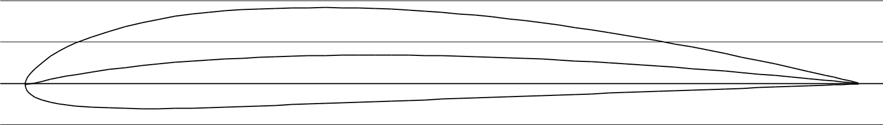

Name = CLARK Y AIRFOIL

Chord = 200mm Radius = 0mm Thickness = 100% Origin = 0% Pitch = 0°

[Powered by TCPDF (www.tcpdf.org)](http://www.tcpdf.org)